Thomas Shields  
11/1/11  
  
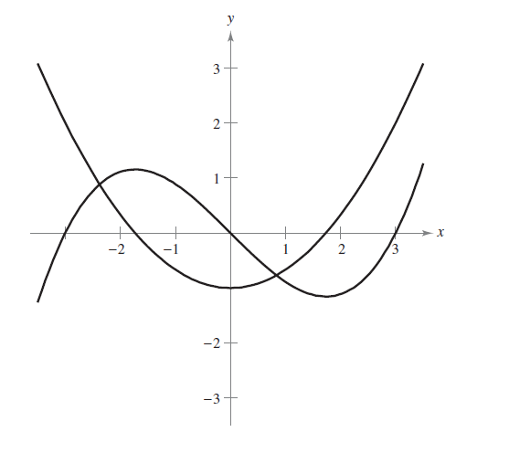

If one of the above functions is *f* and the other is the graph of its derivative, *f’*, it appears that the simpler graph, shaping a U, is *f’*. This is obvious because when the graph of *f* changes direction in the y dimension (thus briefly being “flat” and having a slope of 0) the value of *f’* is 0. For example, at x=1.7 the slope of *f* is 0, and, accordingly, the value of *f’* is 0.

This is also readily apparent when the type of each function is considered. The graph *f* is a cubic function of the form *f(x) = ax3 +bx2 + cx + d*. The graph of *f’* is the expected derivative – a degree lower, thus fitting the form *f(x) = ax2 + bx + c*.